Code No.: |  | HTU/P20 |  | Date Established | 9/11/2017
Responsible  Department |  | Head of Department |  | Date Posted | 9/11/2017
Responsible Executive |  | Head of Department |  | Date Last Revised Revision # 4 | 17/11/23
Quality Nominee |  | Rumiana Bahova Nuseibeh |  | Forward Revision Date: | 17/11/2024

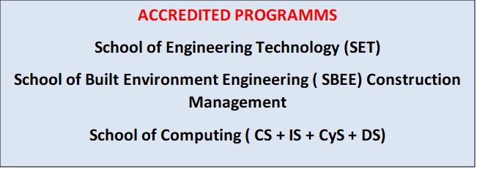

This Document was last revised : 17th November 2023

Delivery/Teaching policy

Summary

This policy is seeking to make sure that the delivery process is being applied in a proper way, to do so, every assessor has to make sure that the subject's contents have been delivered to the
students correctly.

POLICY STATEMENT

• A comprehensive understanding of the unit, which is being taught have been delivered to
Signed by the LIV and IV

DEFINITIONS

• Unit folder: A folder structure which contains the unit specification, assessment planning (AP),
assignment calendar, scheme of work, lesson plan and materials for every unit.
• Unit specification: A kind of support for teachers and students about the unit, which
contains all the requirements that must be achieved to obtain the expected outcomes.
• Assessment strategy: A layout of the unit's structure, which displays the number of Pass
criteria, Merit criteria and Distinction criteria have to be achieved.
• Assignment calendar: Displaying the number of assignments which is being delivered,
and its expected issue and completion dates for each unit.
• Scheme of work (SOW): Demonstrating what the assessor is planning to deliver during
the academic period (Year or Semester), including the total number of weeks, planned
activities and resources.
• Lesson plan: Demonstrating what is being taught in every session, including
objective(s), activities, resources notes and evidences of learning for every session.
• Materials: Detailed explanations about the session's topic.
• Approved assignments: Assignments which have been approved by the internal verifier
and Lead Internal Verifier (If needed) to be issued to the students.
- Assessment Planning , SOW, and AB standard approved templates, will be signed, scanned and send as soft copy to the Quality Assurance Office ( QN) following set deadlines for deliver as per the academic calendar. All IV documentation is archived in a specially designed digital platform – Digital Filing System (DFS) each sememster across all qualifucations.

RESPONSIBILITY
• Assessor: to deliver the unit's contents in a proper way, which can help the student to
achieve the required outcomes, and to provide the required documents, which demonstrating the delivery processes.

• Head of departments: Responsible for following up the teaching processes, and to make
sure that the department has the required unit's folder, which should be up to date.

PROCEDURE

Assessor has to make sure that the following procedures are being applied:
• Comprehensive understanding of the unit specification should be obtained.
• Requirements are needed to be covered in every unit, and should be identified prior to the programme starts.
• Unit contents have to be delivered in a proper way that the student can understand.
• Appropriate guidance to the students regarding the unit’s contents and the assessment has to be provided.
• Essential documents and plans have to be prepared through the unit folder:

The course folder has to be ready for the session, which includes the followings:

▪ Unit specification
▪ Assessment strategy
▪ Assignment calendar
▪ Scheme of work.
▪ Lesson plan.
▪ Materials
▪ Approved assignments

End of Policy.

